Draft agenda

--------------
Teacher Acquisition project – supporting experienced professionals in accessing the teaching profession in vocational education and training

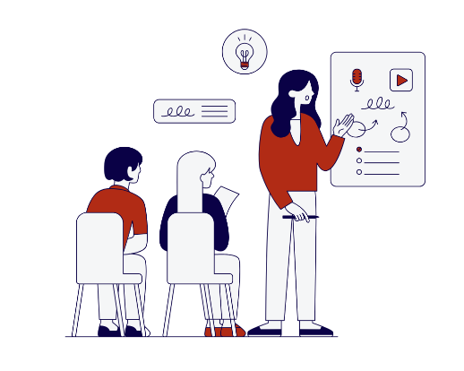
29 May 2024
Time: 9:00 - 17:00
Venue: DCU Glasnevin Campus, Henry Gratten Building, room CG03 – address: Ballymun Rd, Glasnevin, Dublin 9, D09 W6Y4

9:00 - 9:30 | Registration
9:30 - 9:35 | Opening of the PLA and words of welcome  • Marie-Céline Falisse, European Federation of Education Employers (EFEE)  - Paddy Lavelle, Education and Training Boards Ireland (ETBI)
9:35 - 9:50 | Presentation of the TEACHERacquisition project  - Mariana Bernardes, European Federation of Education Employers (EFEE)  Questions & Answers
9:50 - 10:50 | Project Research – presentation and open discussion  - Søren Kristensen, Expert Researcher of the TEACHERacquisition project  Questions & Answers
10:50 - 11:20 | Coffee break
11:20 - 11:50 | - External speaker to be defined  Questions & Answers
11:50 - 12:50 | Teacher acquisition in vocational education and training in Ireland – panel discussion  - [speakers tbd]  - Facilitated by Paddy Lavelle, Education and Training Boards Ireland (ETBI) - tbd
13:00 - 14:00 | Lunch
14:00 - 15:00 | Teacher acquisition in vocational education and training in Europe – poster presentations and open discussion  - [speakers tbd]  Questions & Answers
15:00 – 15:50 | Interactive workshop – Teaching competences analysis  Facilitated by Mariana Bernardes, Marie-Céline Falisse, and Silvia Pesini, European Federation of Education  Employers (EFEE)
15:50 - 16:10 | Coffee break
16:10 - 16:50 | Interactive workshop – Curriculum proposal for an induction programme  Facilitated by Mariana Bernardes, Marie-Céline Falisse, and Silvia Pesini, European Federation of Education  Employers (EFEE)
16:50 - 17:00 | Conclusions and closing of the day

18:30: Departure from the campus to go to the dinner venue
Venue: tbd – address:

30 May 2024

Time: 8:30 - 12:30
Venue: Finglas Training Centre? – address: 1-3 Merrion Rd, Ballsbridge, Dublin 4, D04 PP46
Meeting point: accommodation building, 8:30

9:30 | Arrival at the training centre
9:30 - 10:45 | Welcome words, presentation and visit of the training centre  [school principal or a teacher - tbd]
10:45 - 11:15 | Coffee break
11:15 - 12:30 | Roundtable with the principal, teachers, and students  - [names to be added]  Facilitated by Marie-Céline Falisse, European Federation of Education Employers (EFEE)
12:30 - 12:50 | Learning outcomes and next steps – group reflection
12:50 - 13:00 | Closing remarks

