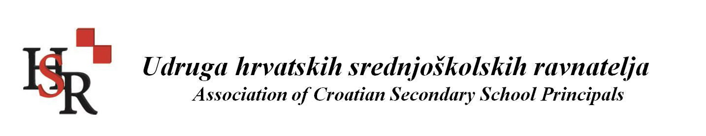

EFEE | THE EUROPEAN FEDERATION OF EDUCATION  EMPLOYERS
Report EFEE Peer Learning Visit to Croatia
17-18 September 2019

Supporting teachers, staff and leaders of education and training institutions: key for making change happen
On 17 and 18 September 2019, the EFEE Peer Learning Visit (PLV) to Croatia took place in Zagreb on ‘Supporting teachers, staff and leaders of education and training institutions’. The event was hosted and co-organised by the Association of Croatian Secondary School Principals (member of EFEE). In total 10 EFEE members participated in the PLV from Belgium (Flemish speaking part), Cyprus, Netherlands, Norway and Slovenia.

Supporting teachers and leaders in secondary education
The first day, participants were welcomed by principal Ljubica Banovic at the Dormitory Marije Jambrišak, where pupils who are not able to stay at home (because of long distances or other social reasons) are offered a home and support along their secondary education studies.
The first speaker of the event, Ms Vesna Anđelić from the Agency for Vocational Education and Training and Adult Education, discussed in her presentation also the theme of ‘support’, but this time directed towards teachers and trainers in vocational education and training (VET) institutions. The shortly presented the tasks of the Agency focusing on among others on in-service training of teachers and trainers, professional and pedagogical monitoring of schools, development of VET curricula, and evaluation and external evaluation of VET schools. Ms Anđelić explained that about 70% of the Secondary Education pupils in Croatia opt for VET schools. However not because it is their first choice, but because of the fact that there are limited places available in Grammar schools / Gymnasia. In order to change this mind-set, and make VET really a first choice, the Agency developed four key priorities for improvement: 1. Enhancing the relevance of VET for the labour market, 2. Improving the quality of VET, 3. Strengthening excellence, attraction and inclusion in VET, 4. Enhancing internationalisation and supporting international mobility of students and teachers. These changes furthermore request excellent teachers and trainers with updated skills and competences both in teaching as well as in their vocational field, as VET teachers and trainers actually have a dual profession. For this purpose the Agency produced in 2018 the concept for the new model for Continuous Professional Development (CPD) for VET teachers and trainers. Before there was no clear link with the classroom, teachers just had to attend a lecture. Now there are 13 core and 12 elective modules delivered through guided training, individual assignment and assessment. Furthermore, teachers have to show that they master new teaching competences that deliver to learning outcomes. With this new model, the Agency aims to: strengthen the pedagogical and specific competences of teachers; improve the professional competences and cooperation with the labour market (teachers and trainers are motivated to gain work experience by working in employer’s premises and establish partnerships with employers); enhance the culture of mobility and to develop competences for lifelong learning. By completing CPD courses teachers can collect credits. The Agency is currently preparing a proposal to link these credits to teaching licences. Practically speaking, the courses are offered in two cycles per academic year during one week. In order to mobilise many teachers, the Agency called upon leaders of VET schools to let their teachers go for one week.
Ms Suzana Hitrec from the Association of Croatian Secondary School Principals continued with a speech on the professional development of school principals in Croatia. First she started with the fundamental question “What is a principal?”. She explained that it would be someone who gives support, evaluate and stimulate the development of quality teachers; sets goals and feel responsible for the whole school, but with an eye for the needs of every individual child; and develops a leading strategy for the resources and management of the school. A complex set of tasks that would need a re-definition of the responsibility’s of principals in Croatia in order to empower principals to execute their role to their full potential. Successful schools needs successful principals, management and administration, she underlined. In view of the global trends and recommendations from the OECD on school leadership, one is therefore currently reflecting on the principal’s responsibilities in the Croatian education system. The principle of ‘shared school leadership’ is challenging to introduce, as the there is currently no support available, there are no assistant school leaders in the system. There is a strong need for developing leadership skills and to making principal an attractive profession, in the current system often only older teachers apply.
In order to improve the ‘professionalisation’ of principals the Association of Croatian Secondary School Principals developed it’s own vision, as Ms Hitrec explained. Principals should receive training before or after their first appointment; after a few years of experiences they should receive a licence; there should be a balance between autonomy (almost non currently) and responsibility (for almost everything currently); quality criteria should be developed for work, evaluation and election (in Croatia principals are elected every 5 year by the whole school community; teachers have a strong vote); there should be developed a mentoring phase for initial principals and strategies for CPD. In the meanwhile, small steps have been taken by the government. An act has been introduced that allows promotion in ranks from mentor to counsellor, and excellent counsellor. However it is for now only a paper-act and hasn’t been introduced yet in practice. Furthermore, this year a module has been introduced for online professional development courses (so-called Loomen), but they are not specially developed for principals, they are the same for teachers. “The way to a quality school is filled with professional development for teachers, principals and whole community”, Ms Hitrec concluded her presentation.
These national practices from Croatia inspired members of EFEE to reflect on their own national systems and to share examples for the benefit of peer learning. It was concluded that the level of autonomy highly divers per country, as well as the level of (de)centralisation. For Slovenia it was mentioned that a couple of years ago the Institute for School Leadership has been established. Here, principals follow during one year a formal programme to prepare them for the role of school leaders. After that principals can follow a mentoring programme within their first five years of being a school leader. Furthermore the institute aims to promote networking among schools and principals. For Norway it was noted that one is not focusing on ‘continuous professional development’ for individuals, but on ‘professional development community’ in order to stimulate the whole school community to take responsibility for development and improvement. Herewith principal is part of the professional community. It is the backbone of the programme to work as a whole school community together, not to take individuals (teachers, principals) out of the school. Therefore trainers from the university go to the school, instead of schools sending their staff and leaders to the university for training. This offered an interesting change of perspective.

Creating a “School of Life” – a curriculum reform process
The second day, participants were welcomed by the Deputy Minister for Education, Ms Lidija Kralj, at the Ministry of Science and Education. She presented the ongoing curricular reform process to establish a “School of Life” aiming to change the focus from teaching to learning in Croatian schools. The reform process started in 2015, but was re-launched in 2017 due to changes in the political governmental leadership. The educational reform foresees changes in teaching and assessment methods, textbooks and learning resources, learning environments, professional development, and curricula (which should become flexible curricula that leave space for the creativity of the teacher). Furthermore it aims to promote administrative unburdening, support to schools from community and companies, meaningful use of technology in support of learning, and support networks that foster the establishment of a culture of sharing and working together. Furthermore, for the first time cross-curricular topics will be introduced in all levels, subjects and schools, being: personal and emotional development, learning to learn, use of ICT, citizenship education, entrepreneurship, health and sustainable development. It is not prescribed how to reach the learning outcomes of these cross-curricular topics, that is left up to the schools, however the Ministry did provide examples on how it could be integrated in subject, Ms Kralj explained.
In March 2018 the next development step in the reform process was taken by kicking off the experimental programme / pilot phase with a select group of schools (based on an open call). The advisors of the Ministry worked closely together with the parents and teachers of the schools to introduce the changes and monitor the outcomes. For this purpose a support network was set up to guarantee direct access to actual information, solving organisational issues, connecting with parents, local community and companies. All with the view to learn from each other. In order to prepare teachers for the reform and to empower them to make the necessary changes in their schools, a mentor system has been set up. Mentors (who are themselves teachers, some of them working at the Ministry, some of them at the pilot schools) train other teachers in small teams. They also introduced the concept of ‘virtual classrooms’ for training. Within this online space the teachers from the pilot schools discussed, guided by the mentors, relevant themes and developed resources for them. Some of these resources are also being used for initial teacher training at university. Regarding the professional development of teachers, the reform has foreseen a big change by turning it from a once a year event into a continuous process. Herewith they use a blended model combining face-to-face actions (e.g. counselling visits on school level to work with teachers, and regional meetings for teachers) and online learning.
Asked about the role of principals in the reform process, the Deputy Minister explained that within the experimental programme also the concept of ‘principal mentors’ has been introduced, as well as virtual classrooms for principals to discuss themes like leadership, coaching, and problem-solving by looking into the organisation and timetable of schools. Furthermore the principal mentors have developed a project to study more in-depth school strategies and leadership models between the pilot schools with the help of international experts (from several countries, some related to knowledge development and other related to policy development) and experts from the Ministry.
She mentioned furthermore that the reform was partly funded by the European Commission through the Structural Reform Support Programme and European Social Fund. “For reforms to happen, we need first of all people, money and time, strength and energy”, Ms Lidija Kralj concluded her presentation.

Conclusions – making change happen
It was noted that Croatia is not the only country in the middle of an education reform. Participants from Belgium, the Netherlands and Norway stressed that currently similar discussions and education reform steps are being taken in their country. The participants reflected on the Croatian education reform process and called it remarkable that the group of mentors is only available for the pilot schools and not all other schools, and that school leaders are not stronger involved, as they form the link between school and the broader community. It was concluded that in order to make change happen in a sustainable way it is key to genuinely involve the whole school community in the development phase, not just afterwards in the implementation phase. This approach of co-creation creates a sense of ownership and strong commitment that empowers all working in the school (but also the wider, local community) to implement the reform plans.

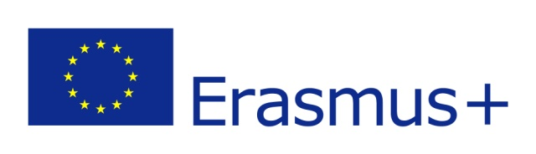
With the support of the ERASMUS+ Programme of the EU

